Simplify each of the following algebraic expressions by performing the indicated operation.



1. (x + 5)(x + 2) 2. (x – 3)(2x + 5)

3. (3x + 5)(2x - 3) 4. (2x – 5)2

Classify each of the following tables as linear, exponential, or quadratic. Write a recursive rule based on the type of function.

5. 6. 7.

|  |  |  |  |  |  |  |  |
| --- | --- | --- | --- | --- | --- | --- | --- |
| **x** | **y** |  | **x** | **y** |  | **x** | **y** |
| -2 | -12 |  | 1 | 5 |  | 2 | 8 |
| -1 | -7 |  | 2 | 10 |  | 3 | 15 |
| 0 | -2 |  | 3 | 20 |  | 4 | 24 |
| 1 | 3 |  | 4 | 40 |  | 5 | 35 |
| 2 | 8 |  | 5 | 80 |  | 6 | 48 |

Recursive: Recursive: Recursive:

8. Write an explicit rule for the quadratic function from problem 7.

9. Find the area and perimeter of each figure given below.

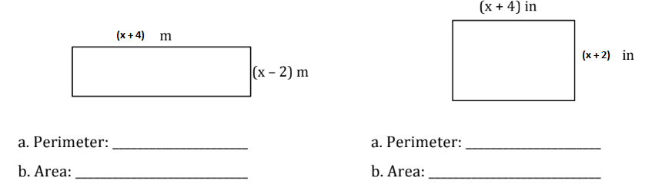

10. Shawn has 150 feet of fence. He wants to create a dog pen where the length is twice as big as the width.

A. What equation would represent the area (A) of Shawn’s dog pen, based on the width, w, of the pen?

B. What will be the maximum area? What dimensions allow for that maximum area?

11. At a festival, stunt devils are launched in large catapults and air cannons. On one launch, the height of the stunt devil in feet above the ground after *t* seconds is modeled by

$f\left(t\right)= -16t^{2}+100t+15.$

When did the stunt devil reach its maximum height?

12. A volcano explodes, shooting lava into the air which is modeled by the equation, $h\left(t\right)= -16t^{2}+88t+300.$ What was the maximum height that the lava reached?

13. Mr. Pagel was kicking a soccer ball to his pal, Cristian, and the height of the soccer ball in meters above ground after t seconds can be modeled by $f\left(t\right)= -4.9t^{2}+25t+3$**.** When was the soccer ball at the same height as when it was launched?

14. A girl is swinging on a swing in her backyard. Her distance over time can be modeled by the

equation $y=t^{2}-3t+3$. How long does it take her to swing back up to the same height she started?

15. The length of a pool is one more than three times the width, *w*. Which equation represents the total area, *A,* of the pool?

A. B.

C. D.

16. Jake has 26 yards of fencing to make a rectangular pen for his baby chicks. What dimensions should he use for the sides of the pen to ensure the maximum amount of area for the baby chicks to live in?

A. 12 yards by 1 yard

B. 10 yards by 3 yards

C. 8 yards by 7 yards

D. 6 yards by 7 yards

17. Rewrite each sum or difference in standard polynomial form.

a.  b. 

18. What is the result when  is subtracted from ?